Q1. Write a query to display all columns and rows from the customer's table.
--print all columns from the table
select * from customers; 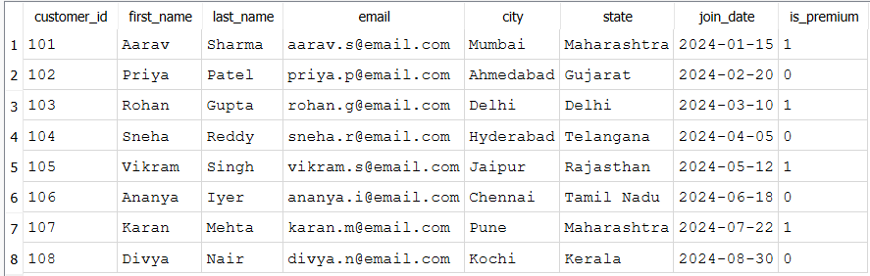
Q2. Retrieve only the first_name, last_name, and city of all customers.
--print specific columns from the table
select first_name , last_name , city from customers ;
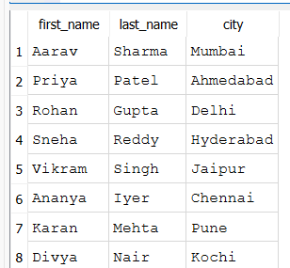
Q3. List all unique categories available in the products table.
--print the UNIQUE categories in the table
select * from products;
select DISTINCT category from products ;
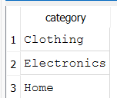
--identifying primary key in the tables
Q4. Identify the Primary Key of each table in the schema. Explain why a Primary Key must be unique and NOT NULL.
A Primary Key uniquely identifies each record in a table.
It must be: Unique : No two rows can have the same primary key value.
NOT NULL : Every row must have a value for the primary key.
This ensures every record can be uniquely identified and maintains data integrity.
PRAGMA table_info(products);
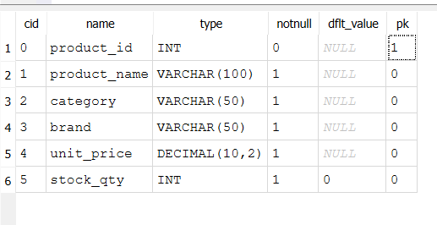

Q5. What constraints are applied to the email column in the customers table? What would happen if you tried to insert a duplicate email?
The email column has these constraints:
1 )NOT NULL 2)UNIQUE
Meaning:
- Every customer must have an email. 2)No two customers can have the same email address.
--Entering Duplicate records for the not null and UNIQUE CONSTRAINT columns
insert into customers values ( 109 , 'Vaishh' , 'Dhanwate' , 'aarav.s@email.com' , 'Nagpur' , 'Maharashtra' , '2024-12-12' , TRUE );
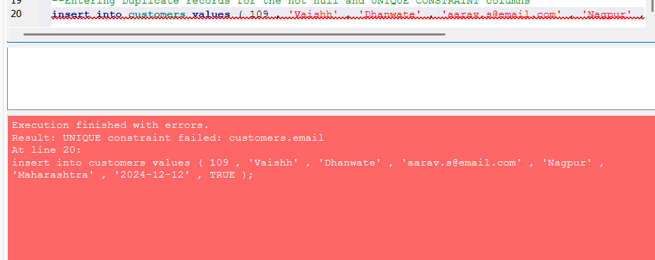
The insertion fails because the email already exists, preventing duplicate customer records.

Q6 .Try inserting a product with unit_price = -50. What happens and which constraint prevents it? Write both the INSERT statement and explain the error.
SELECT sql FROM sqlite_master WHERE type = 'table' AND name = 'products';
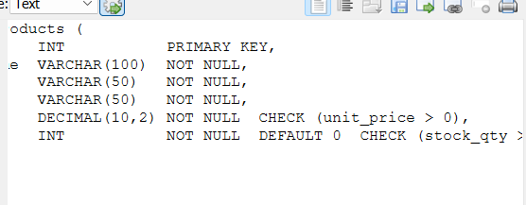
insert into products values (209 , 'USB Cable' , 'Electronics' , 'Boat' , -50 ,100);
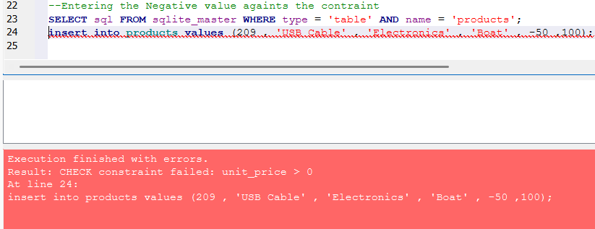
SQLite returns an error because the table has the constraint: CHECK(unit_price > 0)
CHECK constraint failed: unit_price > 0
The CHECK constraint ensures that the product price is always greater than zero, preventing invalid data from being stored.

